Design for Poultry Inventory Management

**Syed Naqvi**

**P2652259**

*May 18, 2021*

Table of Contents

**Abstract** 1

**1.** **Introduction:** 2

Methodology 2

Software Development Lifecycle: 2

Features: 3

System Analysis and Discussion 4

Testing 6

# **Abstract**

In the era of modernization in poultry, it is important to have Inventory management to ensure the quality service to its customers and owners. This will reduce the hectic labor intense work. While reducing the cost of work without reducing the quality of work. This coursework discusses the importance of innovation in poultry using computer and software technology. It elaborates the system using SDLC, class diagram, ER diagrams, and wireframes. Which will further discuss the importance of managing Inventory in poultry using software technology.

# **Introduction:**

The use of software programming is implemented widely in the development of livestock. Most manufacturers are shifting towards modernization through automated software. Agile development is causing every business to overcome the necessity of high labour and sources. Hence, Poultry business owners should implement an adequate time-saving strategy to maintain their trades, manage inventory, analyze deals, and assure consumer gratification. Frenetic work reduced a lot due to their efficacious sale managing software. It can improve customer satisfaction. Numerous causes have inspired this modernization in business that helps taking technological approaches and professionalism. A modernized Inventory management system is created to handle all the necessary information required to manage the business. Databases for orders, Contacts, Inventory, Employee and their tasks are maintained. Design for Poultry Inventory Management intends to possess a precise method for managing and coordinating with the ongoing business traffic. It will help the poultry businesses to increase selling objectives. It will help focus on individual consumer demands and the market perspective. This project intends to introduce more user-friendliness in numerous activities such as record maintenance and securing data in the database. Keeping in track with the Inventory has never been this simpler by having the order id, date, cost, and vendor. The data is stored in the individual databases that make it easier to check updated with the information.

## Methodology

### Software Development Lifecycle:

To make the project easier for stakeholders to understand the design. SDLC plays an important role to make sure that the project is on the right track. "Systems Development Life Cycle is a cyclical methodology, phases repeat, so changes can be made to the design in the next cycle. This makes the process a little less rigid. "Scroggins, R. (2014).

According to Wikipedia: “the software development life cycle (SDLC), also referred to as the application development life-cycle, is a process for planning, creating, testing, and deploying an information system.” Although there are 6 basic methodologies for SDLC to start the project with. We applied waterfall methodology as it was meeting the project’s requirements. Proper planning was done so waterfall method was ideal to work with.

According to Wikipedia: “The waterfall model is a breakdown of project activities into linear sequential phases, where each phase depends on the deliverables of the previous one and corresponds to a specialisation of tasks”. Waterfall model makes the project easy to manage. When money is variable and the requirements are fixed waterfall gives great results in project.

Waterfall model: 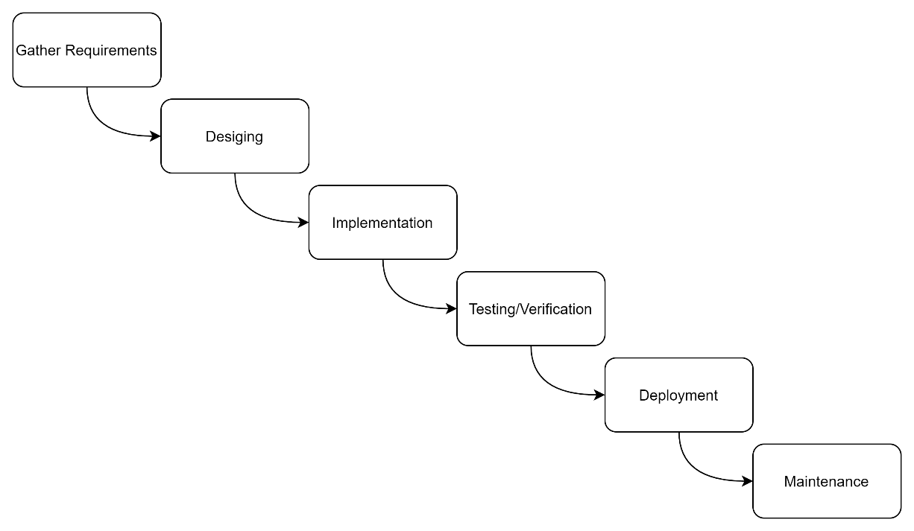

## Features:

* Maintaining the orders:
* This project can monitor and keep the data concerning the orders that poultry business owners purchase. It can keep the Order Details, date, cost, and the vendor’s company.
* Contacts:
* Sustaining contacts has evermore been a hectic task for every business that is related to inventory supervision. This project overcomes the efforts required to keep up with the vendor’s details. It can collect the name, contact, address, company name, deal date, and merchant grade.
* Inventory:
* Poultry business owners seek to hire teams to control their inventory. It essentially undertakes that problem and the excess spending of business interest to maintain the record. It can keep up with the description of the products that are present in the business. Including chicken, fish, egg, feed bags, medicines, and ingredients. With precise details of each stock such as moisture, the solubility of soybean, wheat bran and many others. It has the option to save the vehicle’s number which delivered the goods. It can also keep cost and entering time for the product.
* Tasks:
* Most prominent systems for managing the poultry inventory lack the option to manage tasks. This system provided the facility to manage the tasks for employees. It can save the name, task, duration, and time for that task in the database.

## System Analysis and Discussion

Use case Diagram:

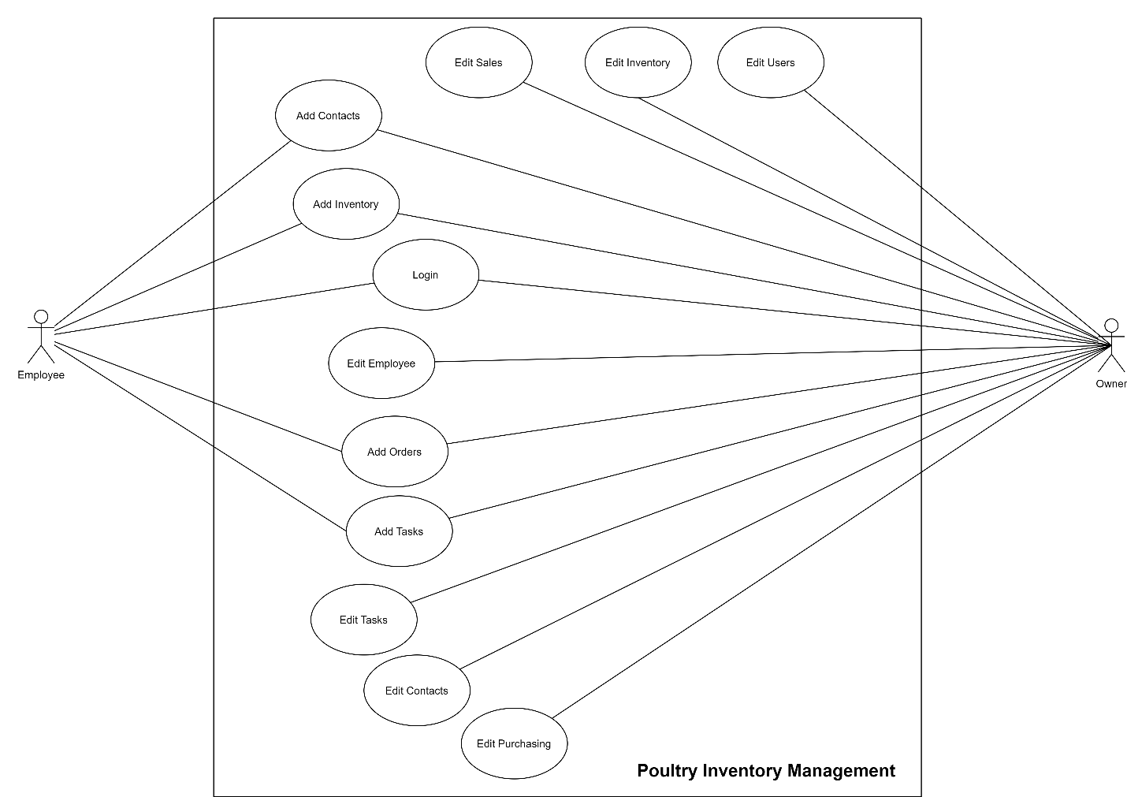

DFD:

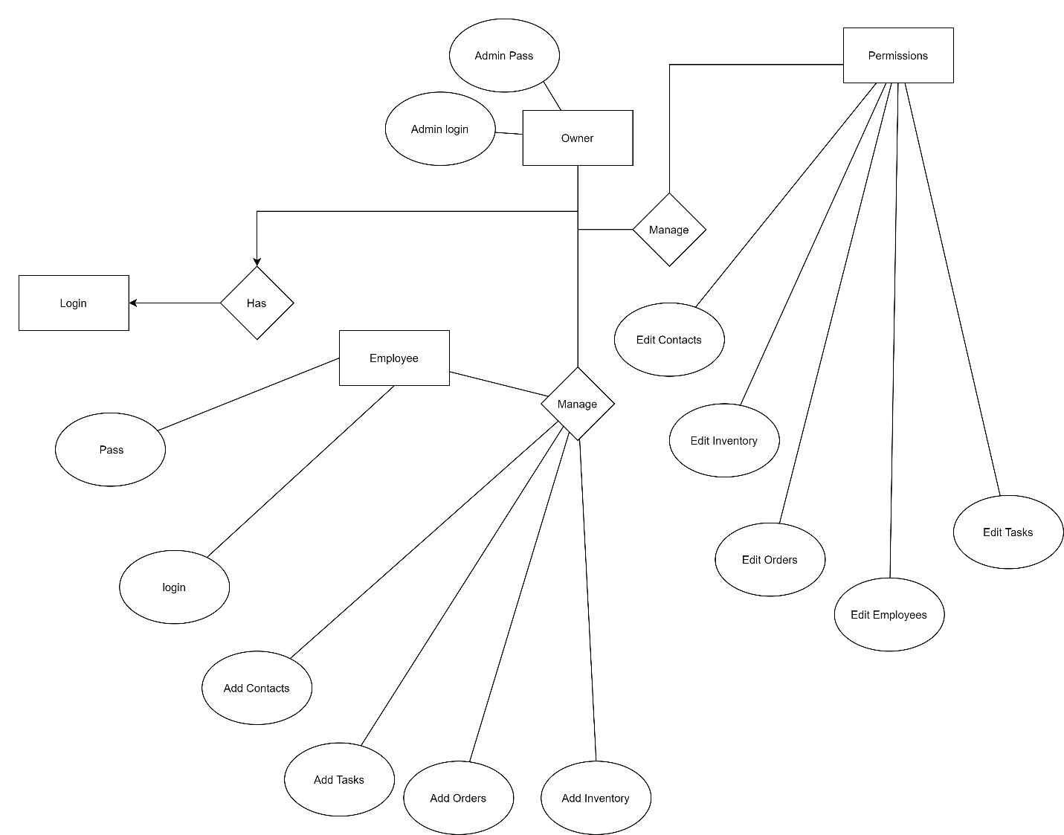

ER Diagram

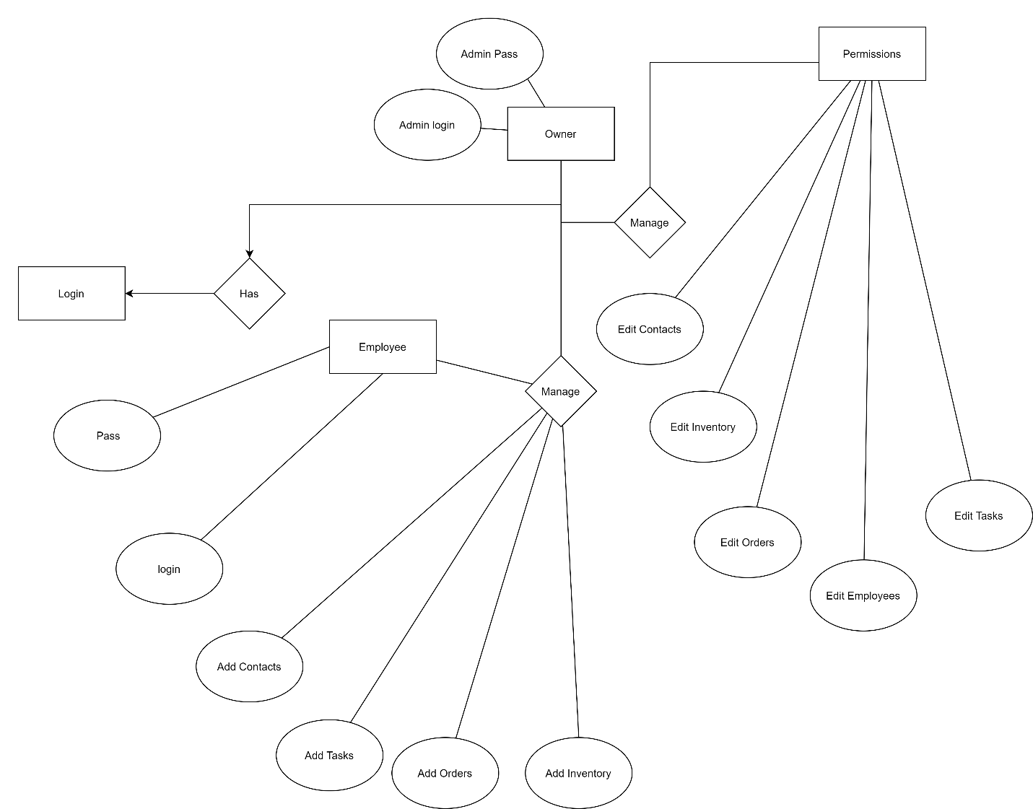

## Testing

The necessity for the inspection run of the system plays an influential role to attain the defects that were made during the process. This enhances the quality and the requisite in future. It affirms that the system has met the elements that were demanded. This allows us to have a focus on the mistakes that could be an error and remain unseen and that would cause a problem for the users. This enhances the inclination to solve the issues effectively. Letting us give a burnish product in the end for its maintenance.

Why testing is important:

Testing the code teaches how to write good code because it allows fixing all bad code. When fixing bugs we learn different ways to solve problems. The number of ways we can break code is immeasurable and that's what makes it so interesting. It also allows us to save time.

References:

Scroggins, R. (2014), SDLC and Development Methodologies. **Global Journal of Computer Science and Technology**, [S.l.]. ISSN 0975-4172. Available at: <https://computerresearch.org/index.php/computer/article/view/148>. Date accessed: 10 june 2021.